Computer Network: NS2 Wired Simulation

Name: Rithvik Rajesh Matta
SRN: PES2UG23CS485
Section: H

Topic:
Wired Simulation using NS2

NSG2.1
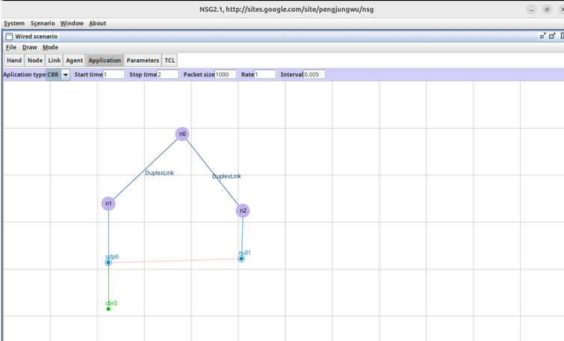

NAM

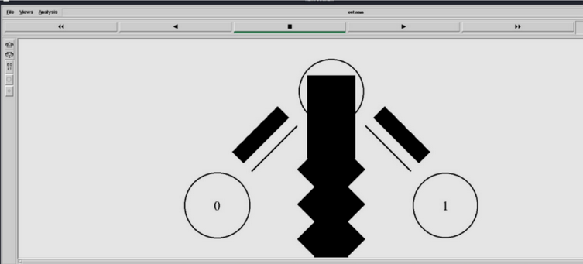

Terminal
